*#Shubhada Jadhav #COBA55*

import pandas as pd import numpy as np

import matplotlib.pyplot as plt import seaborn as sns

from sklearn.model_selection import train_test_split from sklearn.linear_model import LinearRegression from sklearn.ensemble import RandomForestRegressor

from sklearn.metrics import r2_score, mean_squared_error data = pd.read_csv("Uber.csv")

data

|  |  |  |  |  |  |
| --- | --- | --- | --- | --- | --- |
|  | Unnamed: 0 | key | | fare_amount | \ |
| 0 | 24238194 | 2015-05-07 19:52:06.0000003 | | 7.5 |  |
| 1 | 27835199 | 2009-07-17 20:04:56.0000002 | | 7.7 |  |
| 2 | 44984355 | 2009-08-24 21:45:00.00000061 | | 12.9 |  |
| 3 | 25894730 | 2009-06-26 08:22:21.0000001 | | 5.3 |  |
| 4 | 17610152 | 2014-08-28 17:47:00.000000188 | | 16.0 |  |
| ... | ... | ... | | ... |  |
| 199995 | 42598914 | 2012-10-28 10:49:00.00000053 | | 3.0 |  |
| 199996 | 16382965 | 2014-03-14 01:09:00.0000008 | | 7.5 |  |
| 199997 | 27804658 | 2009-06-29 00:42:00.00000078 | | 30.9 |  |
| 199998 | 20259894 | 2015-05-20 14:56:25.0000004 | | 14.5 |  |
| 199999 | 11951496 | 2010-05-15 | 04:08:00.00000076 | 14.1 | |

|  |  |  |  |  |  |
| --- | --- | --- | --- | --- | --- |
| 0 | pickup_datetime 2015-05-07 19:52:06 UTC | | | pickup_longitude  -73.999817 | pickup_latitude \  40.738354 |
| 1 | 2009-07-17 | 20:04:56 | UTC | -73.994355 | 40.728225 |
| 2 | 2009-08-24 | 21:45:00 | UTC | -74.005043 | 40.740770 |
| 3 | 2009-06-26 | 08:22:21 | UTC | -73.976124 | 40.790844 |
| 4 | 2014-08-28 | 17:47:00 | UTC | -73.925023 | 40.744085 |
| ... |  |  | ... | ... | ... |
| 199995 | 2012-10-28 | 10:49:00 | UTC | -73.987042 | 40.739367 |
| 199996 | 2014-03-14 | 01:09:00 | UTC | -73.984722 | 40.736837 |
| 199997 | 2009-06-29 | 00:42:00 | UTC | -73.986017 | 40.756487 |
| 199998 | 2015-05-20 | 14:56:25 | UTC | -73.997124 | 40.725452 |
| 199999 | 2010-05-15 | 04:08:00 | UTC | -73.984395 | 40.720077 |

|  |  |  |  |
| --- | --- | --- | --- |
|  | dropoff_longitude | dropoff_latitude | passenger_count |
| 0 | -73.999512 | 40.723217 | 1 |
| 1 | -73.994710 | 40.750325 | 1 |
| 2 | -73.962565 | 40.772647 | 1 |
| 3 | -73.965316 | 40.803349 | 3 |
| 4 | -73.973082 | 40.761247 | 5 |
| ... | ... | ... | ... |
| 199995 | -73.986525 | 40.740297 | 1 |
| 199996 | -74.006672 | 40.739620 | 1 |
| 199997 | -73.858957 | 40.692588 | 2 |
| 199998 | -73.983215 | 40.695415 | 1 |

199999 -73.985508 40.768793 1

[200000 rows x 9 columns]

data["pickup_datetime"] = pd.to_datetime(data["pickup_datetime"]) missing_values = data.isnull().sum()

print("Missing values in the dataset:") print(missing_values) data.dropna(inplace=True) missing_values = data.isnull().sum() print("Missing values after handling:") print(missing_values) sns.boxplot(x=data["fare_amount"]) plt.show()

Missing values in the dataset:

|  |  |
| --- | --- |
| key | 0 |
| fare_amount | 0 |
| pickup_datetime | 0 |
| pickup_longitude | 0 |
| pickup_latitude | 0 |
| dropoff_longitude | 1 |
| dropoff_latitude | 1 |
| passenger_count | 0 |
| dtype: int64 |  |

Missing values after handling: key 0

fare_amount 0

pickup_datetime 0

pickup_longitude 0

pickup_latitude 0

dropoff_longitude 0

dropoff_latitude 0

passenger_count 0

dtype: int64

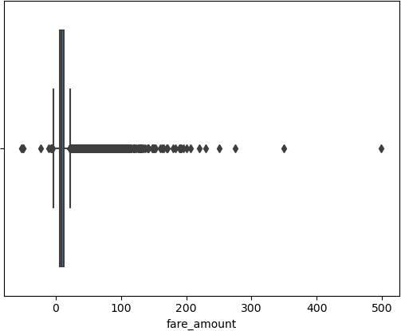

Q1 = data["fare_amount"].quantile(0.25) Q3 = data["fare_amount"].quantile(0.75)

IQR = Q3 - Q1

threshold = 1.5

lower_bound = Q1 - threshold * IQR upper_bound = Q3 + threshold * IQR

data_no_outliers = data[(data["fare_amount"] >= lower_bound) & (data["fare_amount"] <= upper_bound)] sns.boxplot(x=data_no_outliers["fare_amount"])

plt.show()

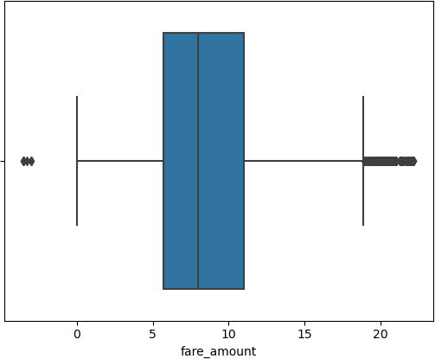

fare_amount pickup_longitude pickup_latitude dropoff_longitude dropoff_latitude passenger_count

AxesSubplot(0.125,0.786098;0.352273x0.0939024) AxesSubplot(0.547727,0.786098;0.352273x0.0939024) AxesSubplot(0.125,0.673415;0.352273x0.0939024) AxesSubplot(0.547727,0.673415;0.352273x0.0939024) AxesSubplot(0.125,0.560732;0.352273x0.0939024) AxesSubplot(0.547727,0.560732;0.352273x0.0939024)

data.plot(kind="box",subplots=True, layout=(7, 2), figsize=(15, 20))

dtype: object

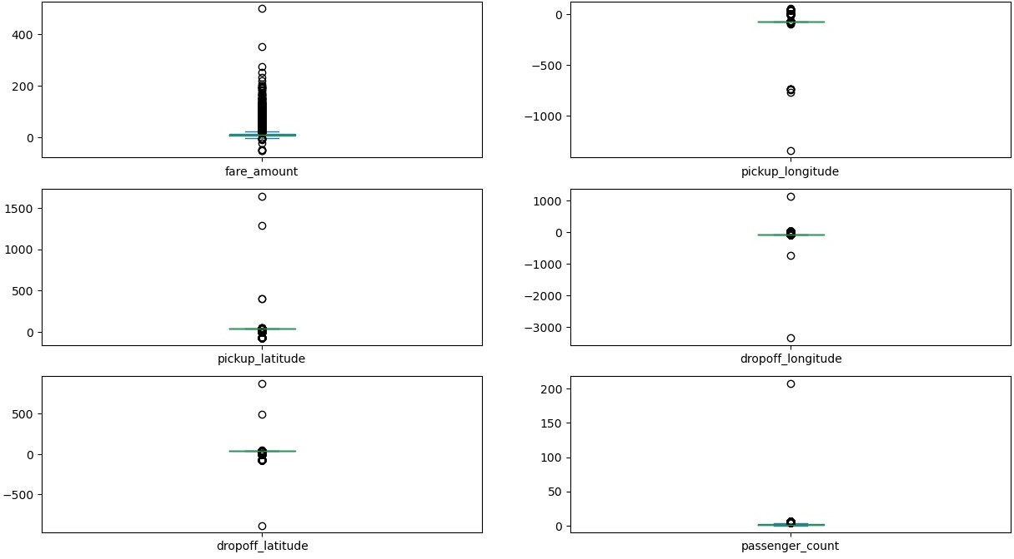

correlation_matrix = data.corr() sns.heatmap(correlation_matrix, annot=True) plt.show()

X = data[['pickup_longitude', 'pickup_latitude', 'dropoff_longitude', 'dropoff_latitude', 'passenger_count']]

y = data['fare_amount']

... 199995 3.0

199996 7.5

199997 30.9

199998 14.5

199999 14.1

Name: fare_amount, Length: 199999, dtype: float64

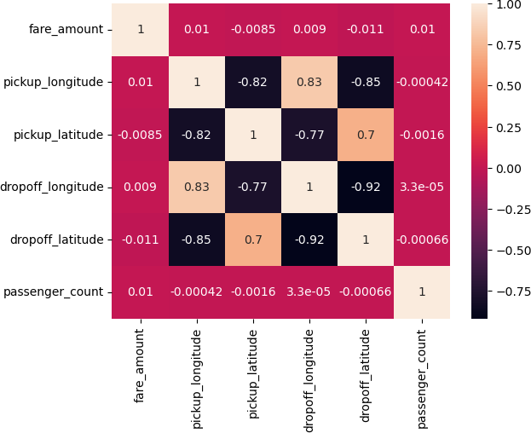

|  |  |
| --- | --- |
| y |  |
| 0 | 7.5 |
| 1 | 7.7 |
| 2 | 12.9 |
| 3 | 5.3 |
| 4 | 16.0 |

X_train, X_test, y_train, y_test = train_test_split(X, y, test_size=0.2, random_state=42)

lr_model = LinearRegression() lr_model.fit(X_train, y_train)

LinearRegression()

rf_model = RandomForestRegressor(n_estimators=100, random_state=42) rf_model.fit(X_train, y_train)

RandomForestRegressor(random_state=42)

y_pred_lr = lr_model.predict(X_test) y_pred_lr

print("Linear Model:",y_pred_lr) y_pred_rf = rf_model.predict(X_test) print("Random Forest Model:", y_pred_rf)

Linear Model: [11.29237916 11.29171388 11.5718662 ... 11.29183291

11.43252639

11.29190248]

Random Forest Model: [ 9.262 5.043 12.547 ... 6.8087 11.279

8.315 ]

r2_lr = r2_score(y_test, y_pred_lr)

rmse_lr = np.sqrt(mean_squared_error(y_test, y_pred_lr))

print("Linear Regression - R2:", r2_lr) print("Linear Regression - RMSE:", rmse_lr)

Linear Regression - R2: 0.00034152697863043535 Linear Regression - RMSE: 10.197470623964248

r2_rf = r2_score(y_test, y_pred_rf)

rmse_rf = np.sqrt(mean_squared_error(y_test, y_pred_rf)) print("Random Forest Regression R2:", r2_rf) print("Random Forest Regression RMSE:",rmse_rf)

Random Forest Regression R2: 0.7011790407391916 Random Forest Regression RMSE: 5.575350372469675